**TITLE**

Auteur 1a*, Auteur 2b, …

*a Affiliation 1*

*b Affiliation 2*

This document must not exceed one page (including figures and references).

Please do not modify the current file format (font : Calibri 12, marge : 2,5 cm, …).

Please underline the name of the speaker.

Figures and references may be included following the template [1, 2], see Figure 1.

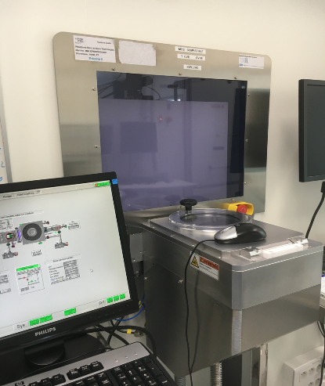          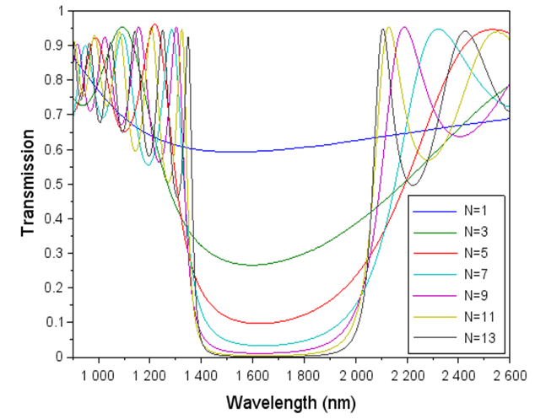

*Figure 1: légende de la figure.*

**Références :**

[1] Auteurs, *Title*, Journal, **Volume**, Page (Year)

[2] Auteurs, *Title*, Journal, **Volume**, Page (Year)

* Corresponding author : [email@univ.fr](mailto:email@univ.fr)